Software Requirements and Design Document

For

Group 24

Version 1.0

Authors:
Isaac Formato
Jack Waite
Luke Stanton
Landon Martin
Trey Corpora

Overview (5 points)

No More Marble Racing is a tower defense video game developed in the Godot game engine. It will consist of grid-like maps where towers can be placed alongside a path that the marbles will race down. There will be waves, currency, and various types of marbles and towers to keep the game exciting. Design aesthetic will be based on the old Marble Run style, with colorful sections of track, funnels, etc.

Functional Requirements (10 points)

- HIGH: Towers. Multiple unique towers with upgradeable tiers, modifying the abilities of the tower, and allowing for different combinations of upgrades.
- HIGH: Multiple unique types of marbles that serve as enemies. They have unique interactions with different towers. Marbles have speed value and health value, which can be damaged separately by different towers and their upgrades.
- MEDIUM: Currency system. This is secondary to towers, it enables upgrading. Currency will be gained upon destroying marbles or destroying your own towers.
- HIGH: Waves. Waves are an incredibly important aspect of this. They will be pre-programmed, so randomness and RNG isn’t something that is a concern. Waves will increase in difficulty by introducing new marble tiers and increasing overall marble count per round.
- USER INTERFACE: Medium. A clean interface is important so that that player can quickly see how many marbles have gotten through, and how many left until they lose. They can see their currency, and easily identify what towers they can upgrade and place and the button to start the next round.
- HIGH: Starting Map. A basic map that is long enough to showcase all above listed elements. Required for every other functional requirement listed. Map design will be based on marble run tracks.

Non-functional Requirements (10 points)
- We would like to have a quick start-up for the game.
- A developer role for us testing would be useful. A way to add infinite money, select any specific round. Send marbles in any order for testing, place and upgrade and tower at any time, etc.

Use Case Diagram (10 points)

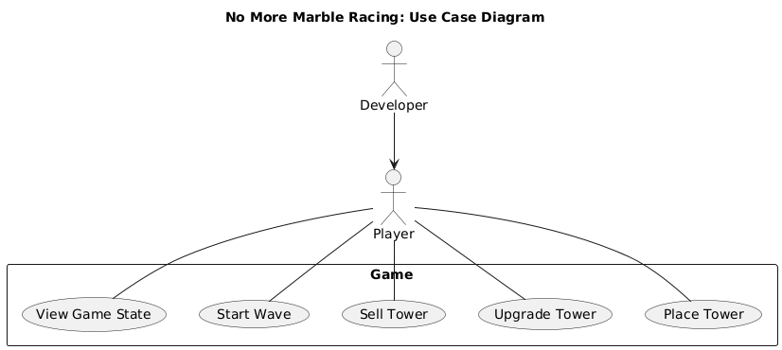

Class Diagram and/or Sequence Diagrams (15 points)
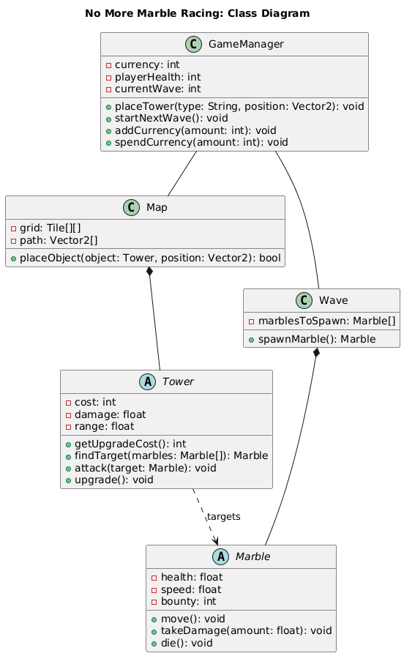
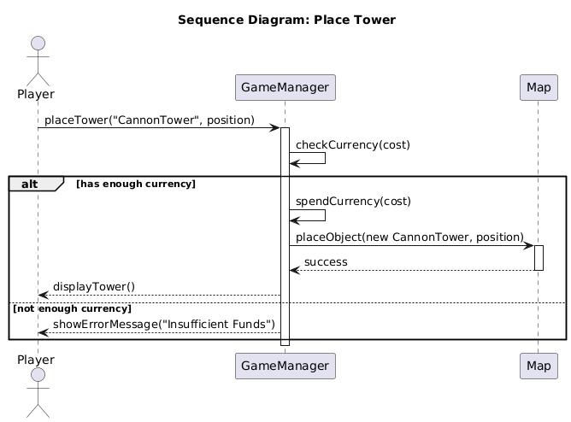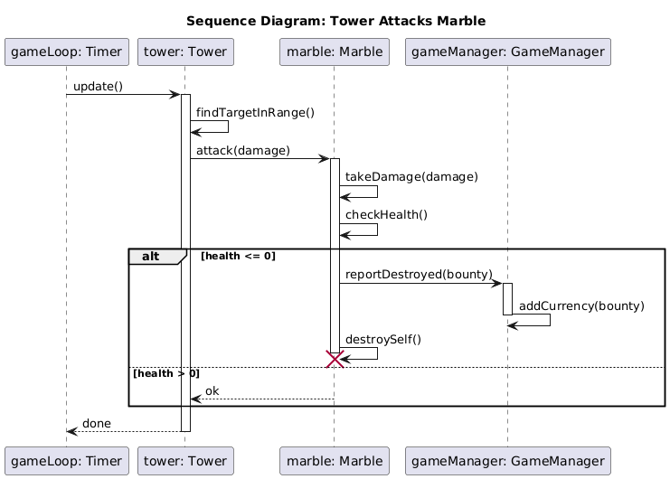

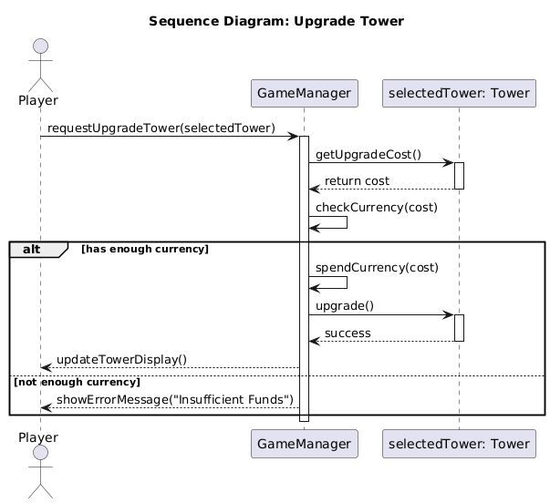

Operating Environment (5 points)

This software will be able to work on Linux, Windows, and Mac as a result of Godot being a cross platform game engine. Pretty much anybody will be able to run the game.

Assumptions and Dependencies (5 points)

In general, one should be able to run this program without a problem. The game engine does an excellent job packaging it for all OS’s. You could not expect to run this on mobile, but in reasonable use-cases on a personal computer, it will run. It is not graphically advanced.

